BeePathNet: Enriching the Urban Jungle with Bees
The BeePathNet project aims to upgrade and transfer the BEE PATH concept, solutions, and results from Ljubljana to other EU cities. It will address urban environmental, biodiversity, and food self-sufficiency challenges linked to urban beekeeping through integrated and participative approaches, and build key stakeholders’ capacity to influence relevant policies, and develop and implement efficient solutions. The BeePathNet project partnerships connect three cities: the City of Ljubljana, Slovenia as lead partner (https://www.ljubljana.si/en/), the City of Bydgoszcz, Poland (http://www.visitbydgoszcz.pl/en/), and the City of Cesena, Italy (http://www.italia.it/en/discover-italy/emilia-romagna/forli-cesena.html).
BeePathNet is an URBACT Transfer network project and is implemented under the URBACT III 2014-2020 programme (http://urbact.eu/) and is co-financed by the European Regional Development Fund (ERDF) (http://ec.europa.eu/regional_policy/en/funding/erdf/).

See more information on BEE PATH: https://www.ljubljana.si/sl/moja-ljubljana/podezelje/cebelja-pot/

Photo – an option (Download photo from virtual office: https://drive.google.com/open?id=1DVyXhjyroR44xjDCf2LSIbEmR7I8C3HI)
Photo description: BeePathNet partners on kick-off meeting, Cesena, Italy, 7th - 8th of May 2018, Source: The City of Cesena archive

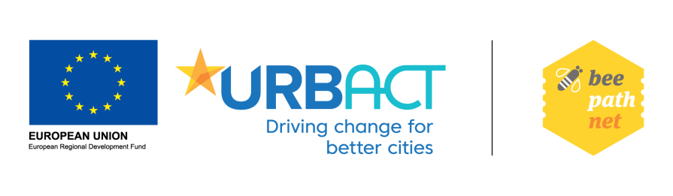
Banner (link it to: http://urbact.eu/):
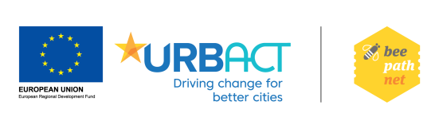

Download banner from virtual office: https://drive.google.com/open?id=1ikSHUFG3stlXu1rawMgWbFuFFLVqA0Zm

